**A PROJECT REPORT ON**

**“APPs in Myanmar”**

*For*

Company Name

**GEO MANDALAR Co.ltd**

**Director**

**U Ravi Chhabra**

**SUPERVISOR**

**Daw Ank Phyu Win**

***Submitted by***

***Ma Khin Su Myat Noe***

***Ma Su Po Po***

***Mg Han Htun Aung***

***Mg Kaung Myat Thu***

***Ma Hla Yamin Htike***

***Ma Hnin Yu Aung***

**UNIVERSITY OF COMPUTER STUDIES ( MANDALAY )**

**Date 4.9.2018**

**Group Members**

|  |  |  |  |
| --- | --- | --- | --- |
| **Roll No** | **Name** | **Signature** | **Date** |
| **5CS-25** | **Ma Khin Su Myat Noe** |  |  |
| **5CS-26** | **Ma Su Po Po** |  |  |
| **5CS-27** | **Mg Han Htun Aung** |  |  |
| **5CS-28** | **Mg Kaung Myat Thu** |  |  |
| **5CS-29** | **Ma Hla Yamin Htike** |  |  |
| **5CS-30** | **Ma Hnin Yu Aung** |  |  |

**( Project Supervisor Name ) Signature / Date**

**Daw Ank Phyu Win**

**CONTENTS**

**Page Number**

**Abstract 4**

**Acknowledgement 5**

**Declaration 6**

**List of Figures 7**

**CHAPTER 1 INTRODUCTION**

* 1. **Introduction 8**
  2. **Background** 
     1. **What is Git? 9**
     2. **What is Github? 9**
     3. **What is Github page? 11**
     4. **What is Firebase? 13**
  3. **Objective of the project 17**

**CHAPTER 2 PROJECT DEVELOPMENT**

**2.1 Design**

**2.1.1 Flow Chart Diagram 18**

**2.1.2 Use Case Diagram 19**

**2.1.3 Description 20**

**2.1.4 Implementation 21**

**CHAPTER 3 EVALUATION AND CONCLUSION**

**3.1 Conclusion 27**

**3.2 REFERENCES 27**

**Abstract**

* Apps in Myanmar are applications which were developed in Burmese Developer
* Users can easily download in this website
* FrontEnd Dev and UI Mockups using Material Design ( HTML, CSS, & Javascript )
* These applications were also developed with firebase hosting and database.

**Acknowledgement**

First, we would like to thankful greatly following persons who have contributed directly or indirectly towards the success of this project.

We would like to respectfully thanks U Kyaw Swar Soe, Rector of Computer University ( Mandalay ), Dr. San San Tin,Pro Rector of Computer University(Mandalay), Dr. Aye Aye Chaw , and Dr. Mya Thida Kyaw, for his kind permission to carry out this project, general guidance and workable environment during the period of study.

We would like to express our Director, U Ravi Chhabra, Director of our Geo-Delta-Mdy group, for his guide way to create our project with successfully and nicely.

We also wish to express our Supervisor, Daw Ank Phyu Win, Lecture of faculty of Computing, Computer University ( Mandalay ), for her helpful advice, helpful encouragement numerous invaluable suggestion and comments.

We also great full to all out teachers for Computer University ( Mandalay ) who have taught and guided us during the period of study. Finally, we are thankful to our follow members who work together in this project and we also thanks again for the unity.

**Declaration**

* The information contained in these applications in Myanmar are true, correct and complete.
* We understand that any misrepresentation may invalidate my application arrangements.
* We noted that all appointments are project details.

**Project Details**

|  |  |
| --- | --- |
| Project Title | Apps in Myanmar |
| Project ID | Geo-Mandalar Company Internship |

**List of Figure**

Figure 1 page-21

Figure 1.1 page-21

Figure 1.2 page-22

Figure 2 page-23

Figure 3 page-24

Figure 4 page-24

Figure 5 page-25

Figure 5.1 page-25

Figure 5.2 page-25

Figure 6 page-26

Figure 6.1 page-26

Chapter 1

**Introduction**

* 1. Introduction
* Apps in Myanmar will involve various applications in Myanmar
* Users can download the applications and also see details that related applications
* Moreover, users can also see publisher’s details who were written these applications

* 1. **Background of the system**

**Introduction to Git, Github and Github pages**

Git, GitHub, and GitHub Pages are all very closely related. Imagine Git as the workflow to get things done and GitHub and GitHub Pages as places to store the work you finish. Projects that use Git are stored publicly in GitHub and GitHub Pages, so in a very generalized way, Git is what you do locally on your own computer and GitHub is the place where all this gets stored publicly on a server.

* + 1. What is Git?

Git is a version control system that tracks changes to files in a project over time. It typically records what the changes were (what was added? what was removed from the file?), who made the changes, notes and comments about the changes by the changer, and at what time the changes were made.

Git is for people who want to maintain multiple versions of their files in an efficient manner and travel back in time to visit different versions without juggling numerous files along with their confusing names stored at different locations.

In the diagram below, each stage represents a “save”. Without Git, you cannot go back to any of the in between stages from the initial draft and final draft. If you wanted to change the opening paragraph in the final draft, you’d have to delete data that you couldn’t recover. To work around this, we use the “save as” option, name it something different, delete the opening paragraph and start writing a new one.

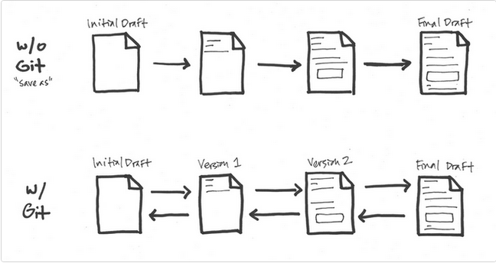

With Git, the flow is multidirectional. Each change that is significant is marked as important in a version, and you proceed. If you need to get back to earlier stages, you can without any loss of data. Presently, Google Docs “revision history” or Wikipedia’s “edit history” work in this sort of fashion. Git is just a lot more detailed and can get a lot more complex if needed.

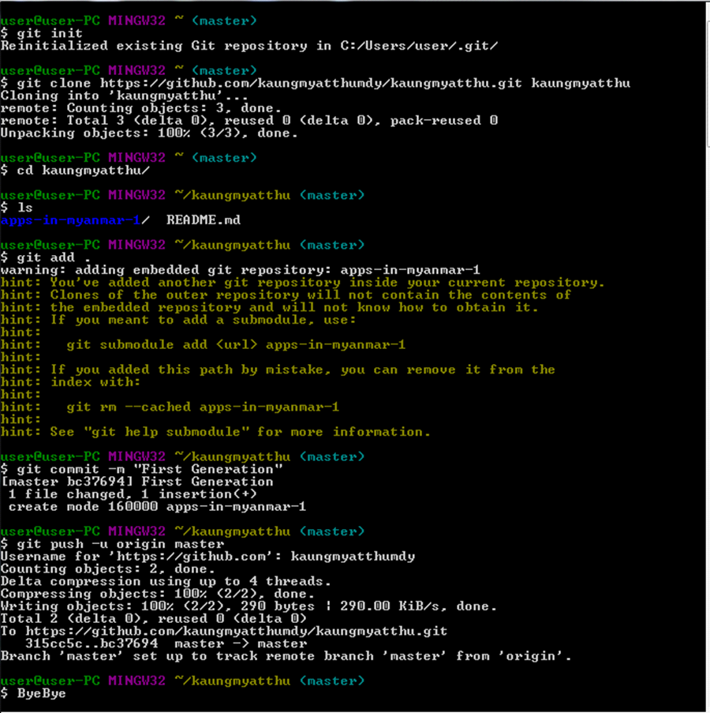

* + 1. **What is Github?**

GitHub is a web hosting service for the source code of software and web development projects (or other text based projects) that use Git. In many cases, most of the code is publicly available, enabling developers to easily investigate, collaborate, download, use, improve, and remix that code. The container for the code of a specific project is called a repository.

GitHub is a code hosting platform for version control and collaboration. It lets you and others work together on projects from anywhere.

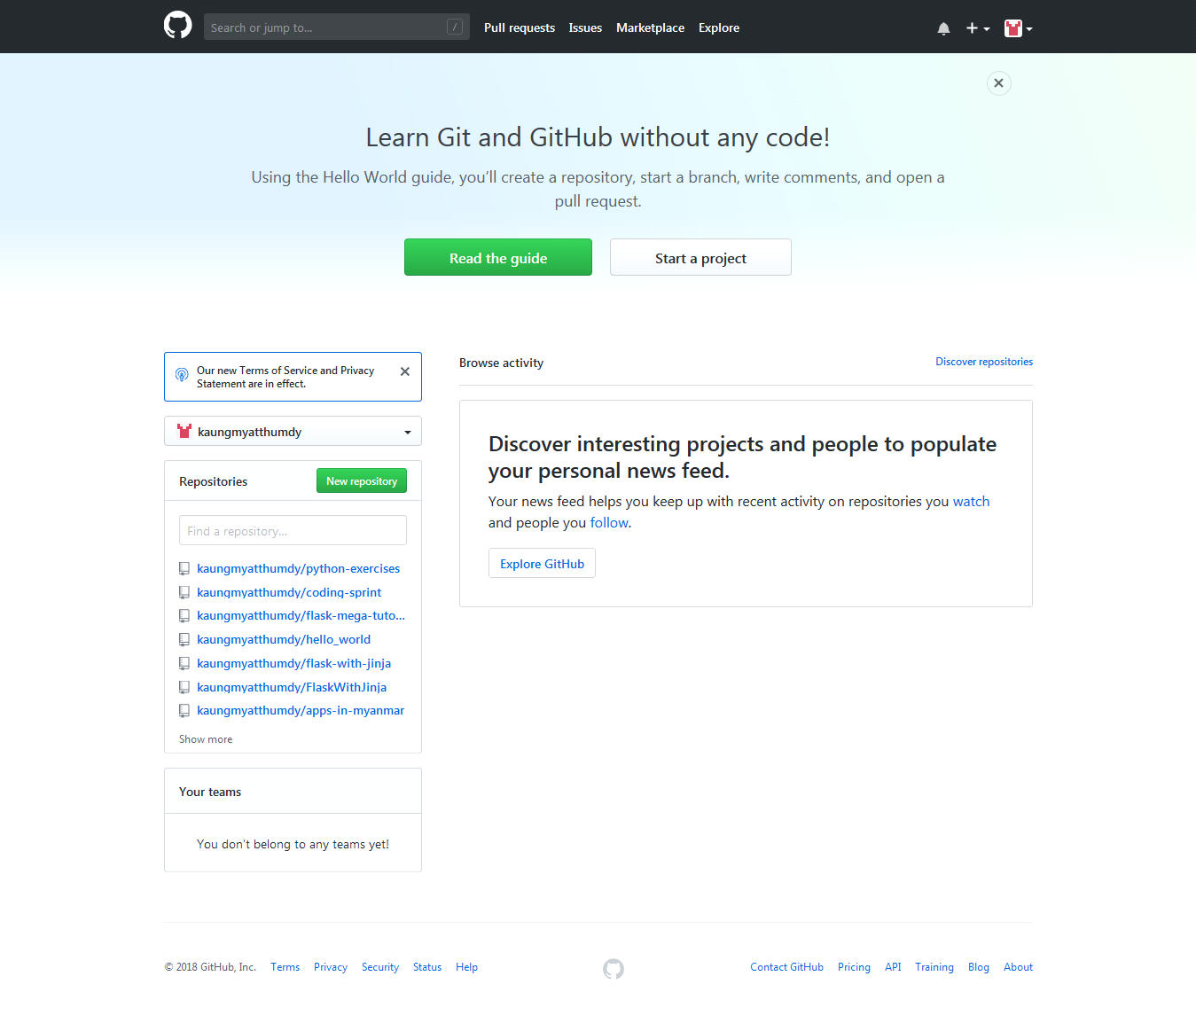

**What are the benefits of GitHub? (OR) What are the main benefits of using GitHub?**

It makes it easy to contribute to your open source projects. To be honest, nearly every open-source project uses GitHub to manage their project.

1. It makes it easy to contribute to your open source projects

2. Documentation.

3. Showcase your work. ...

4. Markdown. Markdown allows you to use a simple text editor to write formatted documents.

5. GitHub is a repository. ...

6. Track changes in your code across versions. ...

7. Integration options.

Understanding the GitHub Flow

Link:

<https://guides.github.com/introduction/flow/>

* + 1. **What is Github page?**

GitHub Pages are public webpages hosted for free through GitHub. GitHub users can create and host both personal websites (one allowed per user) and websites related to specific GitHub projects. Pages let you do the same things as GitHub, but if the repository is named a certain way and files inside it are HTML or Markdown, you can view the file like any other website. GitHub Pages is the self-aware version of GitHub. Pages also come with a powerful static site generator called Jekyll.

GitHub Pages is a static site hosting service designed to host your personal, organization, or project pages directly from a GitHub repository and doesn't support server-side code such as, PHP, Ruby, or Python.

You can create and publish GitHub Pages sites online using the Jekyll Theme Chooser. Or if you prefer to work locally, you can use GitHub Desktop or the command line.

**User, Organization, and Project Pages**

There are two basic types of GitHub Pages sites: Project Pages sites, and User and Organization Pages sites. They are nearly identical but have some important differences.

Project Pages sites are connected to a specific project, and the site files live on a branch within the project repository.

User and Organization Pages sites are not tied to a specific project, and the site files live in a special repository dedicated to GitHub Pages files.

**Building our own site from scratch or generate one for our project**



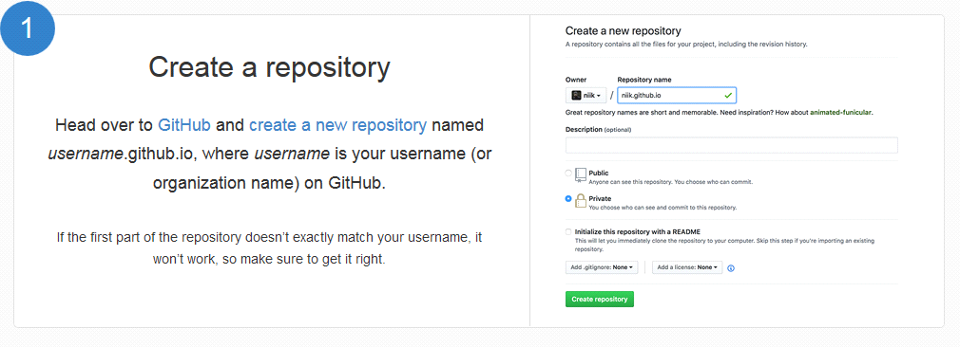



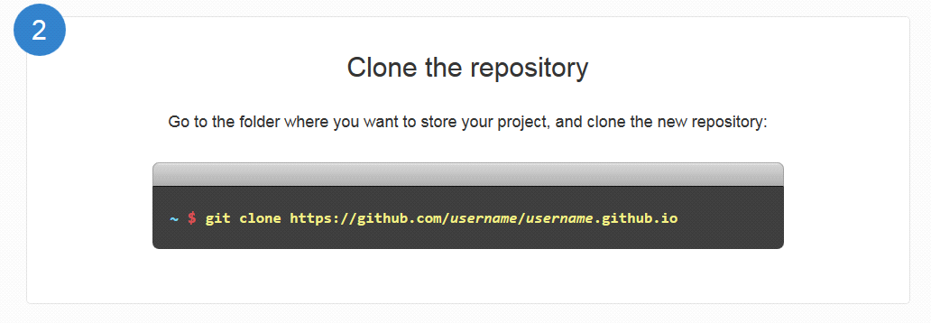

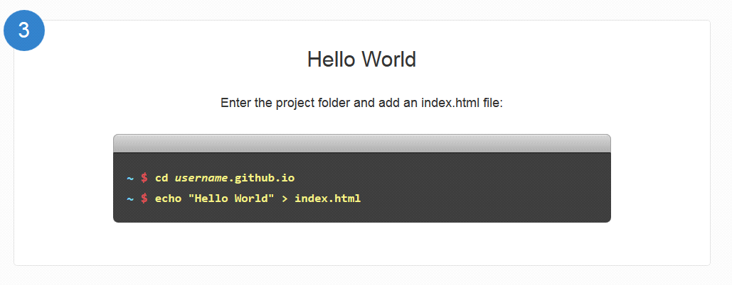

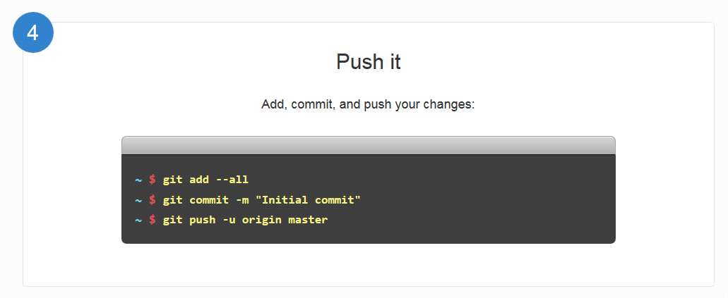

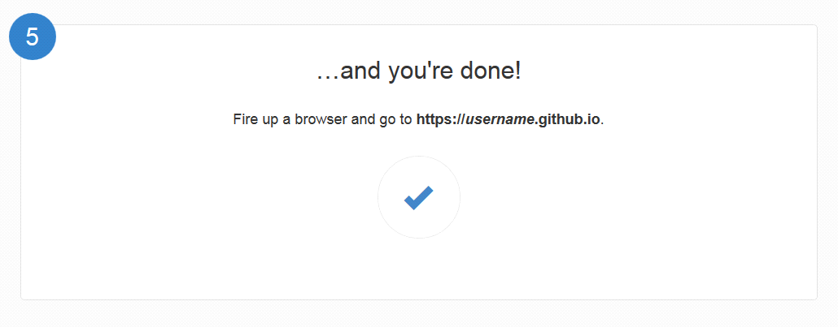

For example

<https://kaungmyatthumdy.github.io>

<https://Mohninyu.github.io>

<https://hlayaminhtike.github.io>

<https://khinhsumyatnoe.github.io>

<https://SuPoPoo.github.io>

<https://hanhtunaung.github.io>



**1.2.4 Firebase**

Firebase Hosting is a static and dynamic web hosting service that launched on May 13, 2014. It supports hosting static files such as CSS, HTML, JAVASCRIPT, and other files as well as dynamic Note.js support through Cloud function.

Real time database, Storage, Authentication future for your user, you can also use cloud function for complicated logics in your app. Firebase is a back-end service that your app can interact with. It has a lot of features such as Real time database, User Authentication, file storage and much more.

**1 Real Time Database**

Firebase provides a realtime database and backend as a service. The service provides application developers an API that allows application data to be synchronized across clients and stored on Firebase's cloud..The company provides client libraries that enable integration with Android, iOS, JavaScript, Java, Objective-C, Swift and Node.js applications. The database is also accessible through a REST API and bindings for several JavaScript frameworks such as AngularJS, React, Ember.js and Backbone.js. The REST API uses the Server-Sent Events protocol, which is an API for creating HTTP connections for receiving push notifications from a server. Developers using the realtime database can secure their data by using the company's server-side-enforced security rules. Cloud Firestore which is Firebase's next generation of the Realtime Database was released for beta use.

**2 Firebase Storage**

Firebase Storage provides secure file uploads and downloads for Firebase apps, regardless of network quality. The developer can use it to store images, audio, video, or other user-generated content. Firebase Storage is backed by Google Cloud Storage.

**3 Firebase Authentication**

Firebase Auth is a service that can authenticate users using only client-side code. It supports social login providers Facebook, GitHub, Twitter and Google (and Google Play Games). Additionally, it includes a user management system whereby developers can enable user authentication with email and password login stored with Firebase.

* 1. **Objective of the project**
* To easy download applications in Myanmar in same place
* To understand the user about apps information without confusing

Chapter 2

**PROJECT DEVELOPMENT**

**2.1 Design**

**2.1.1 Flow Chart Diagram**

Input search data

Display

No

Check the user?

Display App Info

View Detail

Display Home Page

Yes

Firebase Database

Search

Log out

Update the app info

Admin

Enter g-mail and password

Login

Start

End

**2.1.2 Usecase Diagram**

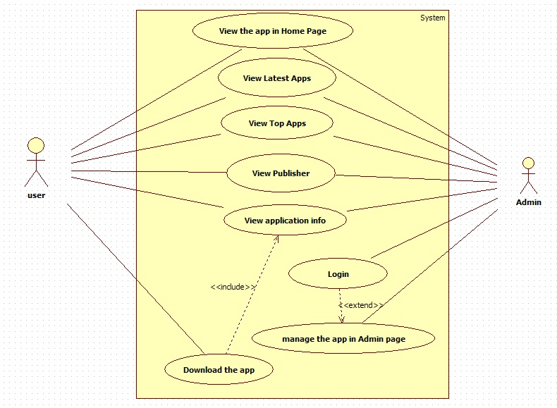.

**2.1.3 Description of the Project**

Application in Myanmar (AIM) is a web application. Application in Myanmar (AIM) is the useful application for user in IT fields. AIM provides the information for application developed in Myanmar. It describes all kinds of application details- Updated date, Size, Installs, Current Version, Requires Android, Offered By and Developer. This system also links with Google Play-store. So, if you want to download the app you want, you can download the app directly. That is why it also performs the third party web site. It has the various user feedback notifications to the admin and can update user's requirement on this system. It can provide user for more accurate information and more effective valuation of the time consuming and cost. It must keep the up-to-date records of all the applications in Myanmar. It can reduce storage size in traditional way. This system is implemented by using HTML, CSS, Javascipt, firebase authentication and firebase database.

**2.1.4 Implementation**

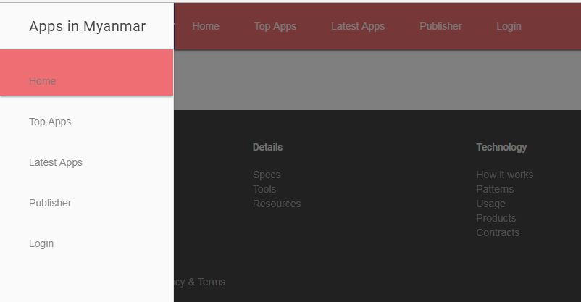

**Figure 1: Home Page of Apps in Myanmar**

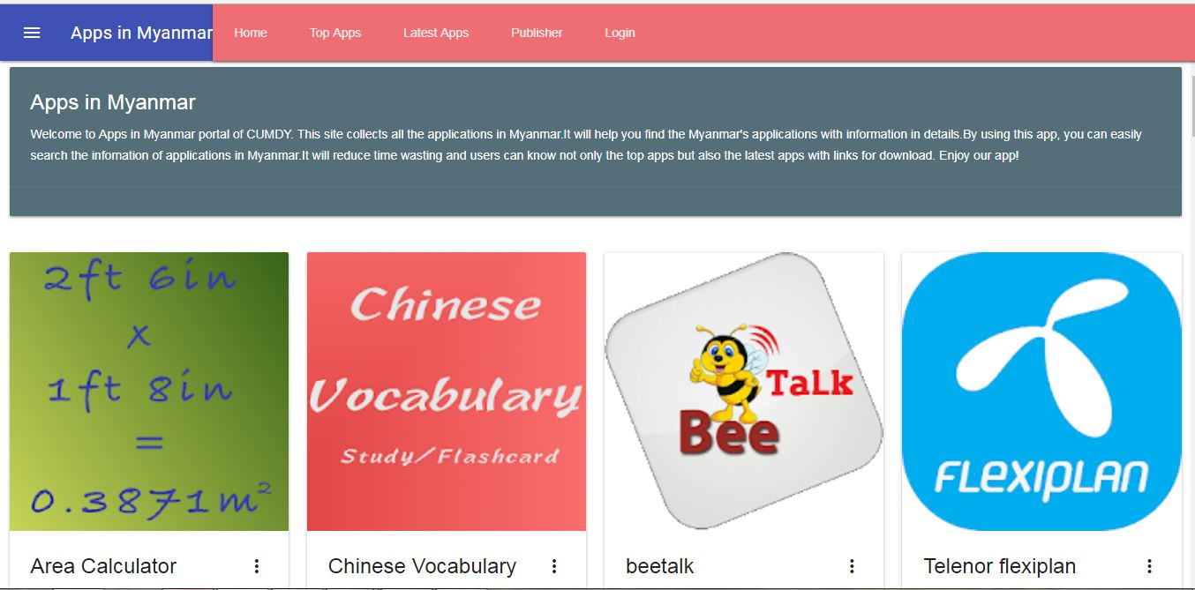

**Figure 1.1: Home Page of Apps in Myanmar**

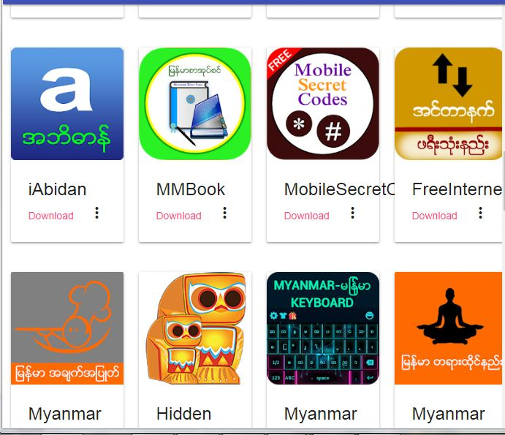

**Figure 1.2: Home Page of Apps in Myanmar**

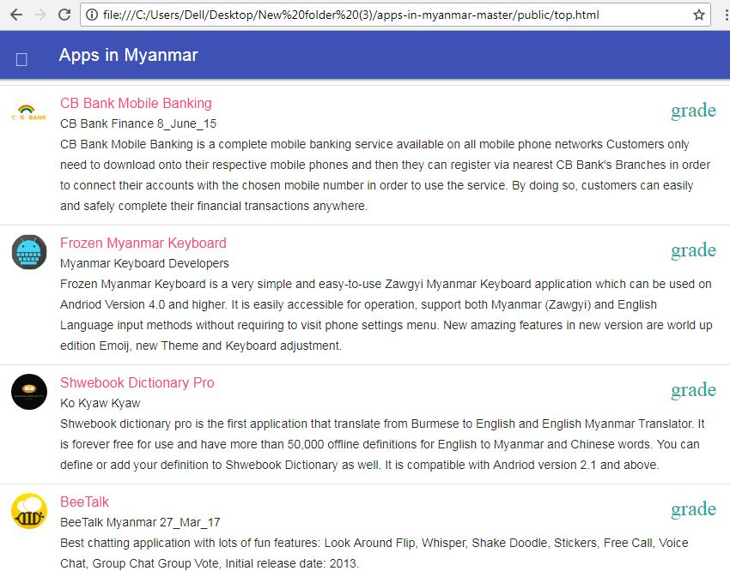

**Figure 2: Top Application of Apps in Myanmar**

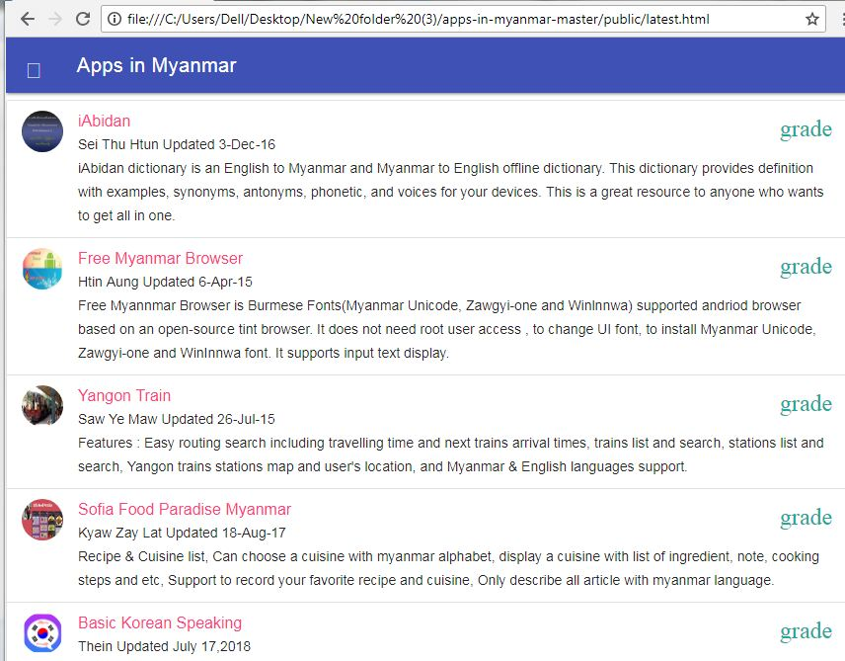

**Figure 3: Latest Application of Apps in Myanmar**

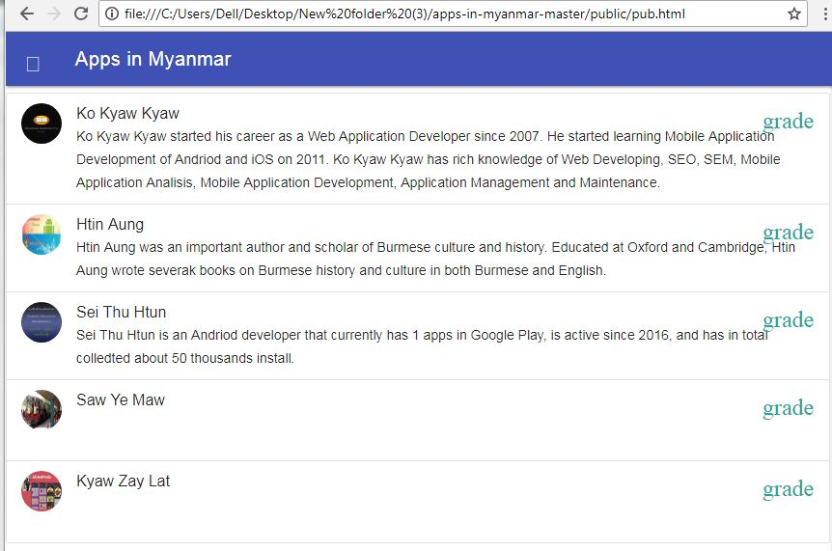

**Figure 4: Publishers of Apps in Myanmar**

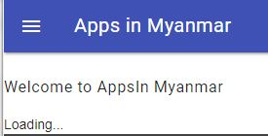 **Figure 5: Login when Offline**

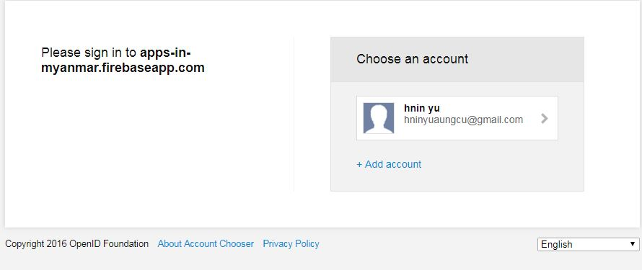

**Figure 5.1: Login when Online**

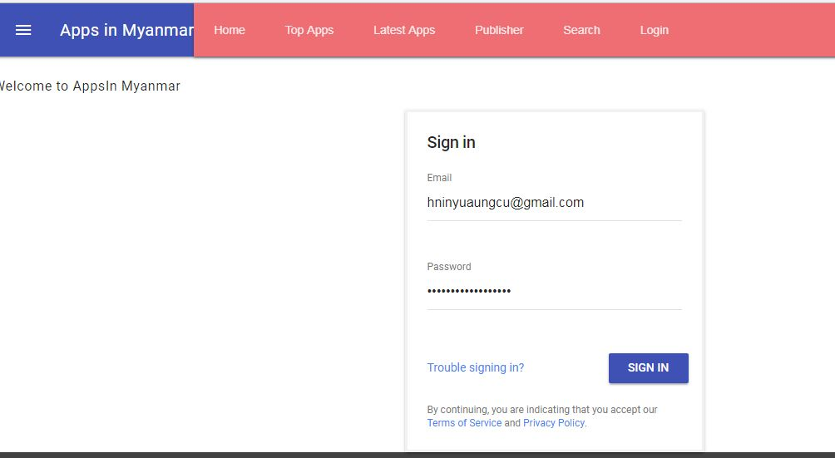

**Figure 5.2: Sign in**

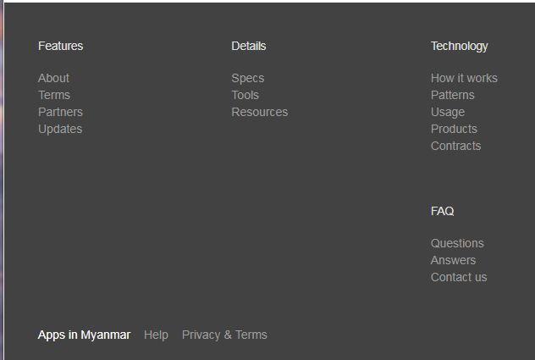

**Figure 6: Footer of Apps in Myanmar**

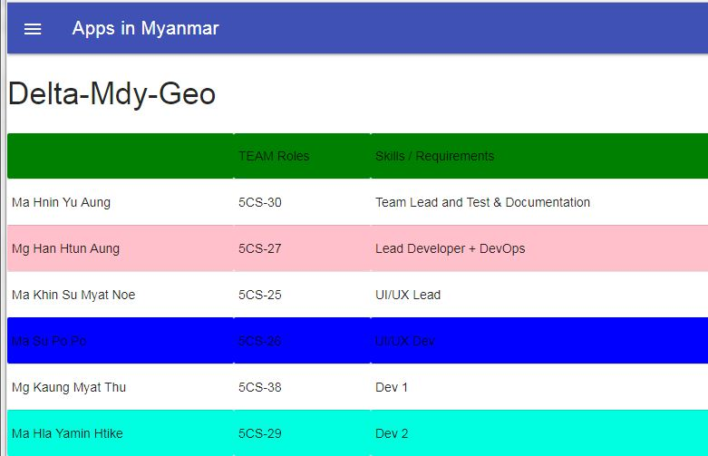

**Figure 6.1: About Page of Apps in Myanmar**

Chapter 3

**EVALUATION AND CONCLUSION**

**3.1 Conclusion**

Application in Myanmar (AIM) assists in automating the existing manual system. This is a paperless work. It can be monitored and controlled remotely. It provides accurate information always. The application together gathered detail information can be saved and can be accessed at any time. So it is better to have a Web Based Information system. The authentication of this system is protected by login form. Therefore, only authorized persons (Admin or Hostel owners) can manage the application information. Normal users can only see the information. All users can get the required information without delay. This system is essential in searching application developed by Myanmar. AIM supports for user-friendly and up-to-date application information. Moreover, with the help of this web based app, not only user can get the application info but also the application can easily be downloaded.

**3.2 REFERENCE**

<http://www.materializecss.com>

<http://www.mdl.com>

<http://www.bootstrap.com>